

**Tribhuvan University**

Institute of Engineering

Purwanchal Campus

A PROJECT PROPOSAL ON

**OPEN LEDGER USING BLOCKCHAIN**

Submitted by

Anuj Timsina [074-BCT-007]

Prajwal Chhetri [074-BCT-023]

Sachi Kamat [074-BCT-032]

Sandeep Thapa [074-BCT-036]

Submitted to

Department of Computer and Electronics Engineering

February, 2021

**ABSTRACT**

Data manipulation is often named as a serious threat to data integrity. Data can be tampered with, and malicious actors could use this to their advantage. Data users in various application domains want to be ensured that the data they are consuming are accurate and have not been tampered with. To validate the integrity of these data, we describe a blockchain based hash validation method. The method assumes that the actual data is stored separately from the blockchain, and then allows a data identifier and a hash of these data to be submitted to the blockchain. The actual data can be validated against the hash on the blockchain at any time. Several use cases are described for blockchain-based hash validation, and to validate the method it is implemented inside an application audit trail to validate the audit trail data. This implementation shows that blockchain based hash validation is able to detect malicious and accidental changes that were made to the data.

Open ledger using blockchain allows users to view all transactions in a transparent way. Blockchain has the potential to be a game-changer in anti-corruption efforts. A blockchain is designed to operate in environments where trust in data/code is greater than trust in individuals or institutions. Records entered in the blockchain are transparent and immutable. When blockchains hold registries of physical items, trusted gatekeepers have to ensure that the physical reality and digital information correspond.

**TABLE OF CONTENTS**

LIST OF FIGURES …………………………………………………………………. iii

CHAPTER1: INTRODUCTION ……………………………………………………… 1

* 1. Background ……………………………………………………………………. 1
  2. Statement of Problem…………………………………………………………... 1
  3. Objectives ……………………………………………………………………... 1
  4. Application……………………………………………………………….......... 2
  5. Project Features………………………………………………………………... 2

CHAPTER 2: LITERATURE REVIEW ……………………………………………… 3

CHAPTER 3: METHODOLOGY ……………………………………………………. 4

3.1 System Design ………………………………………………………………… 4

3.2 Development Platform ………………………………………………………... 4

**LIST OF FIGURES**

**FIGURE PAGE**

Figure 3.1 ………………………………………………………………………. 5

Figure 3.2 ……………………………………………………………………… 6

**CHAPTER 1: INTRODUCTION**

* 1. **Background**

We use open ledger using blockchain to provide transparency of the records to the public.

It is time that world’s citizens learn whether they are getting what they paid for from government contracts. For rich and poor countries alike, getting government contract right is an economic necessity. Transparency can help improve the quality of government contracting. It lowers barriers to entry for firms to bid on work by providing information about previous similar contracts and gives bidders greater comfort that the bidding process will be fair. Governments benefit from increased competition as well as the experience of similar contract models from other jurisdictions, which should improve price or revenue forecasts as well as the quality of contract specifications. Civil society can use contract information to ensure that delivery of services (or the supply of revenues) matches the agreement.

Blockchain is a technology that provides a decentralized “database” on a network that is scalable, secure, tamperproof, and accessible by each peer on the network.

* 1. **Statement of Problem**

The world of work is undergoing radical change. Business has become a real-time experience, we deal with a relentless stream of messages and communications, and we operate in a network of teams. Corruption in the public sector leads to a lack of trust between citizens and government institutions. Transparency of government decisions and open public registries can facilitate the monitoring of registries and reduce the risk for corruption.

* 1. **Objectives**

1. To be familiar with blockchain technology and cryptography.
2. To
3. To learn process for project development
4. To create an open channel so that transactions could be transparent.
   1. **Applications**

Our system can be used to make the transactions public and transparent so that corruption can be prevented at government level.

* 1. **Project Features**
  2. P2P connection to share the personal information.
  3. Cryptography to securely transfer the encrypted information.
  4. Blockchain’s ledger used for storing the records of the contract.
  5. Store the personal information in user’s local storage in encrypted form.

**CHAPTER 2: LITERATURE REVIEW**

Open ledger allows user to view all records but only a specific person or a group of people are allowed to update the blocks. Open ledger can be implemented using blockchain technology. This type of approach falls under the category of public, permissioned blockchain which is open for all to read but only a permissioned group has the authority to write records. Security measures are simpler, transaction rates higher and energy consumption low. All data published on the Ethereum blockchain are publicly accessible. The open ledger using blockchain will help us prevent corruption since all records can be viewed by the public. The records can be trusted since blockchain uses proof of work to add blocks to the blockchain.

**CHAPTER 3: METHODOLOGY**

**3.1 System Design**

A unique identifier is generated for each transaction and this transaction is verified by permissioned verifier before adding it to the blockchain. Each block consists of transactions, previous hash and its own hash value. Each contractor is given a unique login id so that they can access the blockchain to add new blocks containing the transactions of new contracts. The blocks are immutable. Thus, verified records are stored in the immutable ledger which can be accessed by the public. We are using Ethereum blockchain as an immutable ledger for our projects for recording the transparent transactions. The user can also view specific record by specifying the contract name.

For our project development the following aspects are used:

**3.1.1 Blockchain**

Blockchain is a distributed database. Smart Contracts on the Ethereum blockchain allow data to be stored directly inside these contracts as variables. Because of the nature of the blockchain, it is guaranteed that these data can only be changed using the smart contract’s functionality, and every interaction with this contract gets recorded as a transaction on the blockchain.

We are using Ethereum blockchain test network called Rinkeby as our blockchain ledger to store the record of the contracts.

**#####3.1.2 Cryptography**

We are using public key cryptography (asymmetric cryptography) for encryption and validation. Each user is assigned with the keypairs i.e. a public key and a private key. A public key can be shared by the user but the private key must be kept secret. The personal data are encrypted by public key cryptography and sent to the receiver end in a secure manner.

**3.2 Development Platform**

We are developing our project using JavaScript programming language and Solidity for writing smart contracts. We are using Node.js, Express.js for back-end development and React.js for front-end development. Since our team has 4 members, we are developing our project using GitHub which makes it easier to contribute in the project. Also, the IDE we are using is Visual Studio code.

**#####3.3 Block Diagram**

Presents

credentials

Signs

credentials

Verifies

Contract

Issue claims

Verifier

Public

Unique Identifier

Blockchain

**Figure 3.1: Block diagram of open ledger system**

**Use Case Diagram**

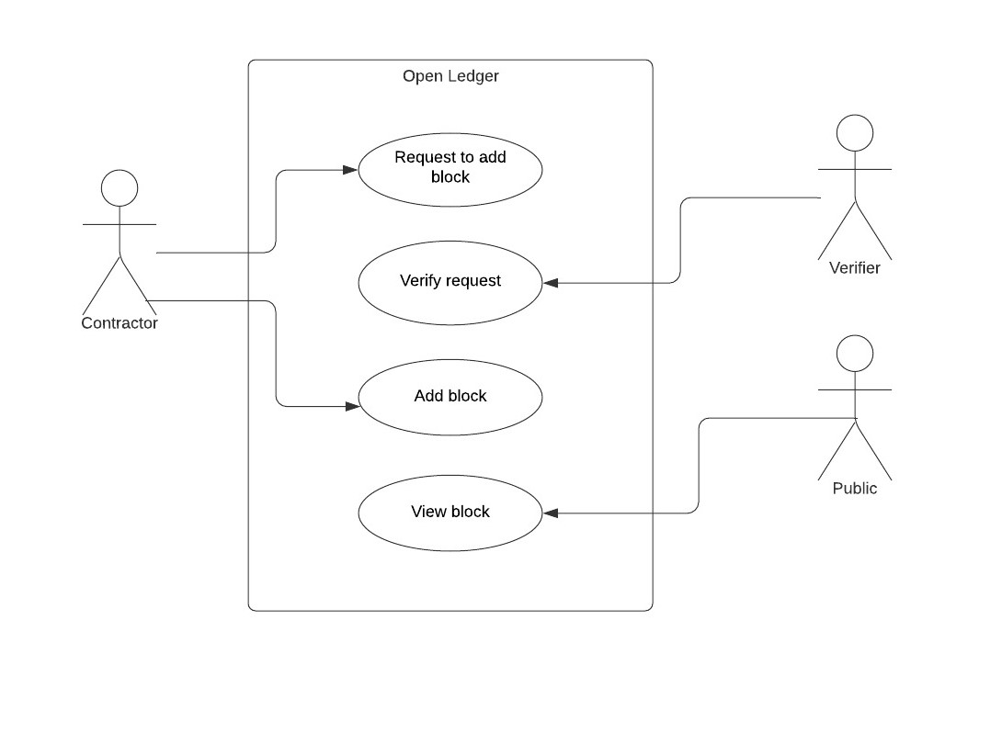

Figure: 3.2: Use Case Diagram